SmartWaterFountain

**Phase3**

**NAME: NAVURU LAKSHMI NARASIMHA**

**N ID: au723921106010**

**EMAIL: navurulakshminarsimhath@gmail.com**

# Introduction

## Objective:

Today, more people around the world have pets than ever before.According toAmerican Pet ProductsAssociation’s survey in 2020, 67% of U.S. households own a pet which is about 84.9 million homes. This proportion has been increased by 20% in thirty years [1]. Breakdownofthepettypes,catsanddogsarethemost popularanimals,theycontributeto about 80% of all pets. Same trend happens all over the world. On average, one in three households own adog globally and abouta quarter of householdsworldwide own acat[2]. Both cats and dogs prefer flowing water.Asource of fresh clean running water can encourage pets to drink.Drinking a certain amount of water daily plays an important role in long-term health for pets, especially cats.As a result, a water fountain is essential to most

householdshavingcatsordogsaspets.However,wecannotensurethewaterqualitywhen we are away from home for several days. It can happen when pets have finished all remaining water in the water fountain, or water has been polluted somehow by the pet.

Thesecancausethepettobeunwillingtodrinkwaterfromthefountain.

Our goal is to design a smart water fountain that can monitor the water quality and automaticallyreplacewaterwhenpolluted(nothealthy)orrunningout.Wewillusesensors to measure the water quality. Common water quality measurement factors include

temperature,Ph-value,conductance,turbidityandhardness[3].Consideringthepollutionat home can only affect limited factors, we choose temperature, Ph-value and conductance to be the three properties used for calculating water quality in our water fountain. These data will be collected, calculated, and reflected to the user in terms of “Good”, “Average” and “Bad”. The water fountain is also designed to self-filter the water every time when water is pumped through the submersible water pump.

## Background:

There havebeen quite alot ofwaterfountain products onthemarket[4],while mostofthem have only filtration as an extra function besides providing running water. [5] The size of the waterfountainlimitsthecapacityofthewatersourcethatmostwaterfountainscannotstore enough water for multiple pets to drink in several days.

Ourwaterfountaincanbeconnectedtoanextrawatersourcethat providesenoughwater for long-term usage. The link is adaptable to universal water bottles for convenience. The sufficient water source as well as automatic replacing and refilling function enable pet owners to leave home for several days without worrying about water supply for pets.

## PhysicalDesign:

Apictorial representation of your project that puts your solution in context. Not necessarily restrictedtoyourdesign.Includeotherexternalsystemsrelevanttoyourproject(e.g. if your solution connectsto aphone via Bluetooth, drawa dotted line between your deviceandthe phone). Note that this is not a block diagram and should explain how the solution is used, not a breakdown of inner components.

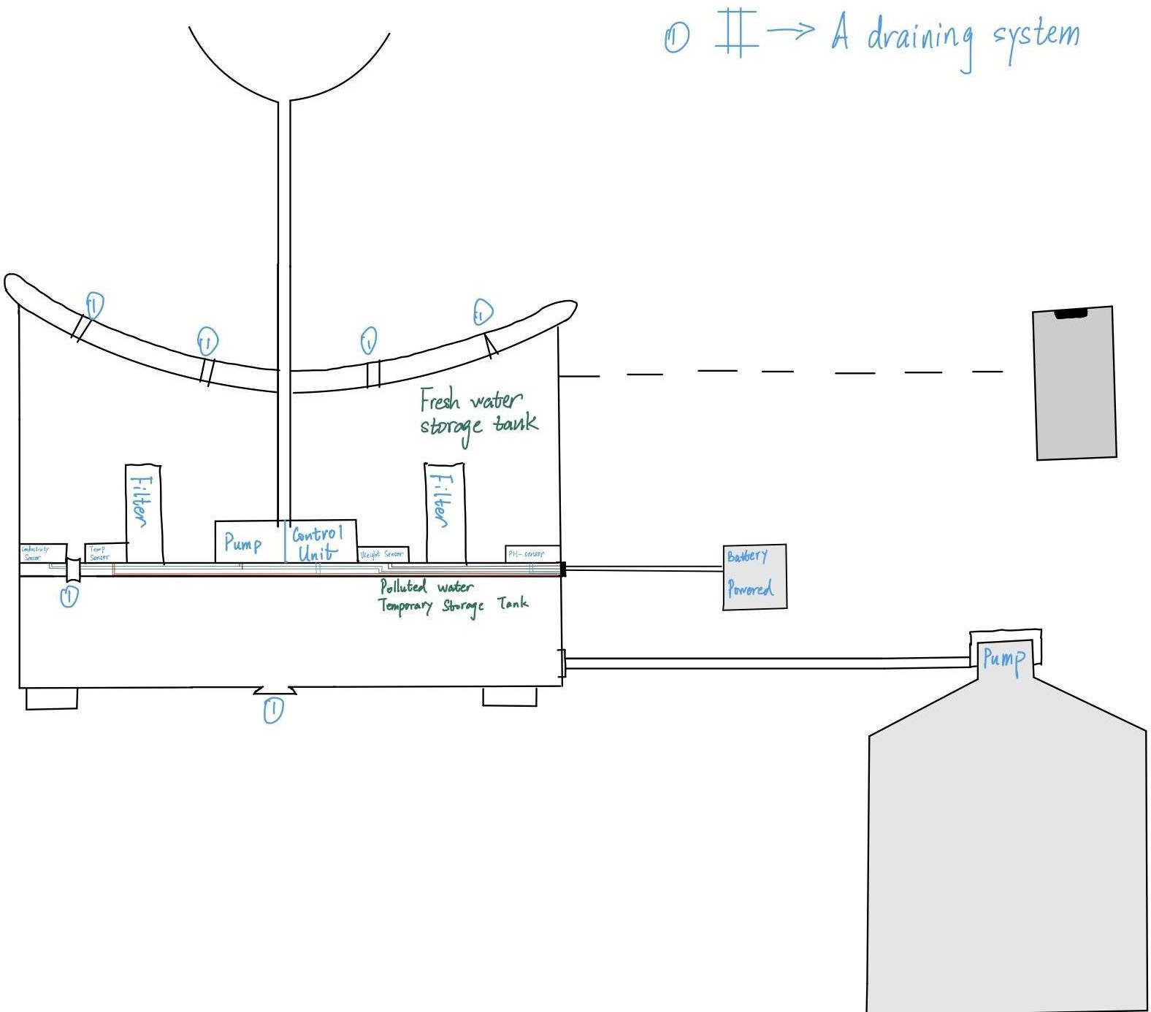

*Figure1SmartFountainPhysicalDiagram*

## High-levelrequirementslist:

* Able to drain the polluted water and replace it with fresh water. Specifically, the polluted waterwillbedrainedbyamotor-controlledvalvetothe“pollutedwatertemporarystorage tank” part.After completing the draining process, fresh water will be pumped from the generalwater supply(asdescribed intherightdown cornerofthe physicaldesign, Figure 1).
* Thefountainmustaccuratelymonitorthewaterquality,includingmeasuringwater temperature up to 48.89C and pH values between 6.5 and 8.5.
* Able to be connected to the users’devices through WIFI. Prompt feedback from the smartwaterfountaintousers’interfacewithrelevantinformationincludingtheremaining water level and water quality index: ‘Good’, ‘Average’ and ‘Poor’.

# Design

Theblockdiagrambelowisageneraldesignofoursolution.Wedivideourdesignintofour modules, including Power Supply, Control Unit, External Control, and Mechanical Unit.

Detailsofeachunitispresentedinthediagramanddescribedinthenextsection.

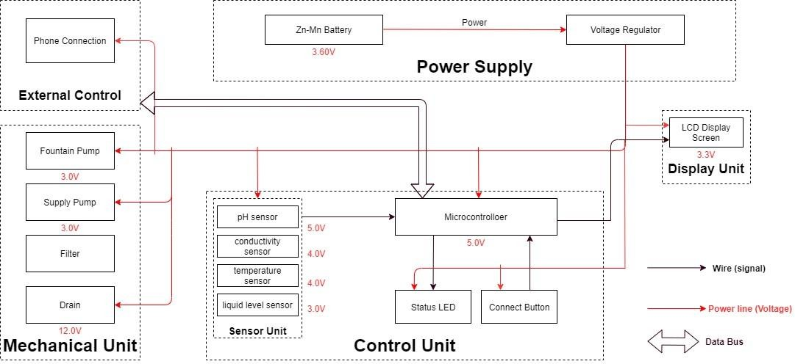

*Figure2BlockDiagramofSmartWaterFountain*

## SensorUnit

This block contains thefour sensors.The data acquired fromthesensorswill be transmitted to the control unit. Control unit will then have some logic designed to send corresponding signals to controlother blocks ofthe waterfountain.Atthe sametime, thedisplay screenon thewaterfountainwilldisplaythereadingsalongwiththedeterminedwaterqualityleveland remaining water quantity.

For the PH-value sensor, temperature sensor and conductivity sensor, values will be retrievedandcalculatedtodeterminetheoverallwater qualitylevel.Whenpoorwaterquality is determined, the water replacement procedures will take place. The weight sensorreadings will be used to determine the amount of fresh water left in the water tank.

### TemperatureSensor:

Awater-proof temperature sensor is going to be used. Part number from sparkfun is: DS18B20[6].Thistemperaturesensoriscompatiblewitharelativelywiderangeofpower supply from 3.0V to 5.5V. The measured temperature ranges from -55 to +125 celsius

degrees.Between-10to+85degrees,theaccuracyisupto+-0.5degrees.Thissensorcan fulfill all requirements needed for this project.

### PH-sensor:

PH value is a valued indicator of water quality. This PH-sensor[7] works with 5V voltage, whichisalsocompatiblewiththetemperaturesensor.Itcan6measurethePHvaluefrom0 to 14 with an accuracy of +- 0.1 at the temperature of 25 degrees.

### Conductivitysensor:

Conductivitysensorisalsopartofthewaterqualityassessment.Theinputvoltageisfrom

3.0to5.0V.Theerrorissmall,+-5%F.S.Themeasurementvaluerangesfrom0to20ms/cm which is enough for water quality monitoring. [8]

### LiquidLevelSensor:

This sensor [9] is responsible for reflecting how much freshwater is left in the water tank. When the water level is low, fresh water will be pumped to the water tank to ensure the waterfountainkeepsrunningwithfreshwater.Thissensoris0.5Watts.For waterlevelfrom 0 to 9 inches, the corresponding sensor outputs readings from 0 to 1.6. From that, the quantity of freshwater left can be determined.

## Displayunit:

### Screen:

Thescreenwillbeusedtodisplaythereadingsfromthesensorsinareal-timemanner.[10] In addition, other necessary information will also be displayed.As described in the sensor part, the water quality and remaining water quantity will be displayed. The screen will be programmed so that it makes it easy for users to read information.

This20*4LCDdisplayscreenisgoingtobeusedtodisplaytherelevantinformation.After programming the screen, a conclusion of water quality(Good,Average, Poor) will be displayed along with the remaining water level.

## PowerSupplyUnit

### Zn-MnBattery

TheZn-Mnbatterymustbeabletocontinuouslysupportthefunctioningofthecircuit,display unit, and the mechanical unit.

Requirement:Commercialbatterieswillbeusedtomaintainacontinuous3.60Vpower supply for at least 24 hours. If the chosen battery is not powerful enough, 120V power outlets will be considered.

### Voltageregulator

Theintegratedcircuitwillregulatethepowersupplyforeachmoduletomaintaintheir

functionality.Thischipmustbeabletohandlethemaximumvoltagesuppliedbythebattery (3.60V ± 0.5V) while ensuring the voltage at each module does not exceed their limit.

Requirement:Mustmaintainthermalstabilitybelow100°C.

## MechanicalUnit

### FountainPump

The fountain pump [14] must maintain a continuous water supply through the fountain mechanism.Thepumpmustwork24hoursaday,7daysaweekunlesstheusermanually turns off the power supply.

Requirement1:Thefountainpumpmustliftacylindricalwaterstreamof diameter6mmfora height of 400mm.

Requirement2:Thefountainpumpmustserveforadurationof 2yearswithoutmaintenance or replacement under heavy workload.

Requirement3:Thefountainpumpshouldhaveanoperationalconditionaround3V,200mA.

### SupplyPump

Thesupplypumpmustfunctionwhenalowwaterlevelalertisraised.Whilenowatersupply is requested, the pump must prevent water flow between the main supply and the fountain.

Requirement:Thesupplypumpshouldhaveanoperationalconditionaround3V,200mA.

### Filter

ThefiltermustmaintainthewaterqualitythroughcontrollingthepHvalueandconductivityof the water.

Requirement1:Thefiltermusthaveacostlessthan$5eachforfrequentreplacement.Each new filter must serve a duration no less than 3 month.

Requirement2:Thefiltermustbedesignedforeasyremovalandinstallation,whilethe connection mechanism must have a low degenerate rate when submerged in water.

### Drain

Thedrain[13]mustbeabletoholdandreleasewaterinthefountain.Whenwaterinthe fountain should be replaced, the faucet should automatically drain the fountain once instruction is received from the integrated circuit.

## ControlUnit

Thisunitcontainsthecontrolunitwhichdoesthefollowingthings:

* When the weight sensor reports a weight less than the minimum weight setting, the controlunit willsendanalert signaltotheuserandthencontrolthewatersupplyunittorefill the water fountain with a certain amount of water.
* Computesthewaterqualitywithdatatransferredfromthethreesensorsinthewater quality module and sends the result in terms of “Good”, “Average” or “Bad” to the user.
* Ifthewaterqualityis“Bad”,thecontrolunitwillcontrolthedrainmoduletodrainthe water in the fountain and then control the water supply to refill.
* Waterqualityresultissenttotheuserwithwirelessconnectionandscreendisplayas described above in the display unit.(unsure about keeping this function)

## RiskAnalysis:

### ControlUnitBlock:

One of the most challenging points in this project is the precise control of the control unit between different blocks. To react accurately and promptly based on the results from the sensorsisthekey.Thecontrolunitneedstoaccommodatethemechanical andtheelectrical part so that the pumps, draining system can work collaboratively smoothly. From acquiring the data from sensors, analyzing the data, communicating and displaying the data to users, and then sending signals to activate the corresponding actions(drain or add fresh water), these are all to be performed by the control unit.Thus, it is the block that brings the greatest risk.

We will divide all the overall control unit functions into three parts: data retrieving, data manipulation,datadelivering.Dataretrievingisthelogicusedtoreaddatafromallsensors. Necessary algorithm is to be written to ensure successful and accurate data acquisition.

Data manipulation is the process of calculating the water quality levels, and the formula to integrateallthedatatoproduceacredibleresult.Thedatadeliveringisusedtoconnectthe

control unit to the screen, displaying the necessary information as described above. This partwillalsoberesponsibleforbuildingtheconnectionbetweenthewaterfountainandthe users’ phones through WIFI. **2.6.2 Mechanical Unit Block:**

This is very challenging and extremely important.As most of the components will beexposed towater.Sensors,pumps,filters,draining systemmotors are all to be placed inthe water tank. This means that we need to ensure no water can leak into the electrical-related mechanicalparts.Thisputspressureonthedesignandalsotheimplementation.Inaddition, the motor-controlled valves used to drain the polluted water need to be firm when closed.

Otherwisethefreshwaterwillbeleakingtothepollutedwaterstorageandthewater consumption will be uncontrollable.

To achieve those points, we will make sure the designs are carefully implemented. Theactualbuildingprocessforthecontainershouldbeprovedbeforeplacingtheelectronicparts in.

# EthicsandSafety

## MechanicalUnitBlock

### I-1ofIEEECodeofEthics:

QuotedfromIEEE Codeof Ethics[11]: “Tohold paramount the safety, health, andwelfareof the public, to strive to comply with ethical design and sustainable development practices, to protecttheprivacyofothers,andtodisclosepromptlyfactorsthatmightendangerthepublic or the environment.”

We will carefully choose the materials used to build the container. Non-toxic are sure to be used. We will prefer using reusable materials. In addition to that, the users can choose to buy reusable bottles of water for the freshwater supply for the water fountain. Those universalwaterbottlesaresafeandreusable.[12]Aspecialconnectorwillbedesignedand theuniversalconnectionis tobeused.Afterthewaterinthebottleisusedup,this reusable bottle can be recycled and reused. This is the most environmentally-friendly solution and complies with the IEEE Code of Ethics #I-1. It not only improves the practicality, convenience, and reduces the future cost when using the water fountain.

### IIofIEEECodeOfEthics:

Quotedfrom[11]:“II.Totreatallpersonsfairlyandwithrespect,tonotengagein harassment or discrimination, and to avoid injuring others.”

As mentioned in the 3.2, the mechanical unit involves electronic components that are physically placed in thewater tank.The consequence can be serious if the leakproofness is not performed properly. To maintain a safe, convenient using experience, we will be responsiblefortestingandensuringallcontainersmeetthedemand.Theseactionsmustbe taken to ensure the safety of using the water fountain and protect the others.

### I-6ofIEEECodeOfEthics:

Quotedfrom[11]:“tomaintainandimproveourtechnicalcompetenceandtoundertake technological tasks for others only if qualified by training or experience, or after full disclosure of pertinent limitations.”

All team members involved in the development of the water fountain have completed “LaboratorySafetytraining”andhavegainedrequiredandnecessaryknowledgeindealing withemergencysituations.Incaseof accidents, properreactionwillbemadetoensurethe safety of people and property to the largest extent.